Owlet Dream Duo™ (3rd Generation)
Smart baby health and sleep monitoring system with HD camera and medically certified sock

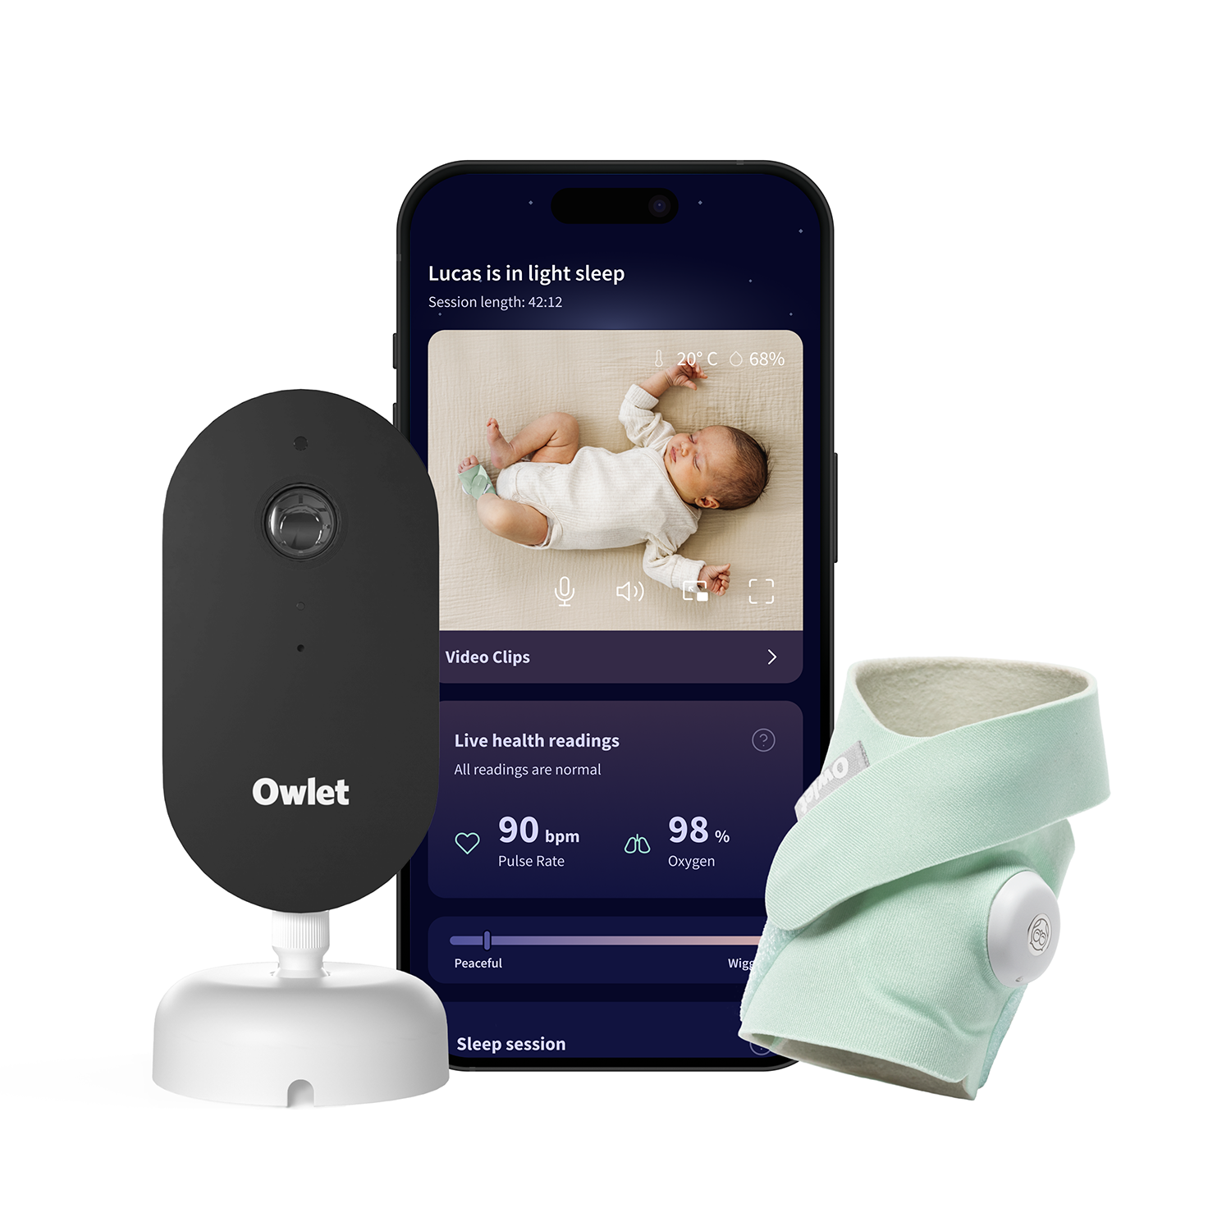

Product Description
Owlet Dream Duo™ (3rd Generation) is the most complete baby monitoring system on the market – combining the medically certified Dream Sock®, the smart HD Dream Sight™ camera, and the Owlet Dream App in one connected solution.
From day one, Dream Duo helps you feel calm and confident: it monitors your baby’s pulse rate, oxygen level, and sleep trends in real time while streaming clear 2K HD video with night vision straight to your phone.
If your baby’s readings leave safe zones, you’ll receive an instant alert so you can act quickly. Smart sleep tracking helps you understand your child’s needs and avoid restless nights. Plus, built-in room temperature and humidity monitoring ensures the sleep environment is safe and comfortable.
Dream Duo uses hospital-grade pulse oximetry, is protected by advanced encryption, and keeps improving through software updates. It’s more than just a monitor – it’s your trusted parenting partner, providing peace of mind night after night.

Key Benefits
- ✅ The only medically certified all-in-one baby monitor – health, sleep, and video monitoring in one app
- ✅ Live pulse, oxygen, and sleep tracking with clinical accuracy
- ✅ Real-time alerts if readings leave safe zones
- ✅ Dream Sight™ HD camera with 2K video, night vision, and two-way audio
- ✅ Predictive sleep tracking – shows wake windows and helps smooth routines
- ✅ Temperature and humidity monitoring for safe sleep conditions
- ✅ Owlet Dream App – one place for all insights and alerts
- ✅ Privacy protected – 256-bit encryption and advanced security
- ✅ Trusted brand – Owlet has already monitored over 1.7M babies and more than 17 trillion heartbeats worldwide

What’s Included
- HD camera Dream Sight™
- Dream Sock® sensor + 4 fabric socks (0–18 months / 2.5–13.6 kg)
- Charging base
- Wall mounting kit
- Certified cable guards
- Power adapter + USB-C cable
- Free access to Owlet Dream App

Tech Specs
- Video: 2K HD, night vision, 130° wide angle lens, 4× digital zoom
- Audio: Two-way talk
- Smart Alerts: Pulse, oxygen, cry, sound, motion
- Sensors: Pulse oximeter + sound & motion detection + temp/humidity
- Connectivity: Dual-band Wi-Fi (2.4 GHz & 5 GHz), Bluetooth
- Battery (Dream Sock): up to 16h; 20 min quick charge = 8h, full in 90 min
- App: Owlet Dream App (iOS 14+, Android 7+)
- Certifications: Medically certified, FCC, CPSC, ASTM, 256-bit encryption

✨ Owlet Dream Duo™ – more than a monitor. Your trusted parenting partner.

